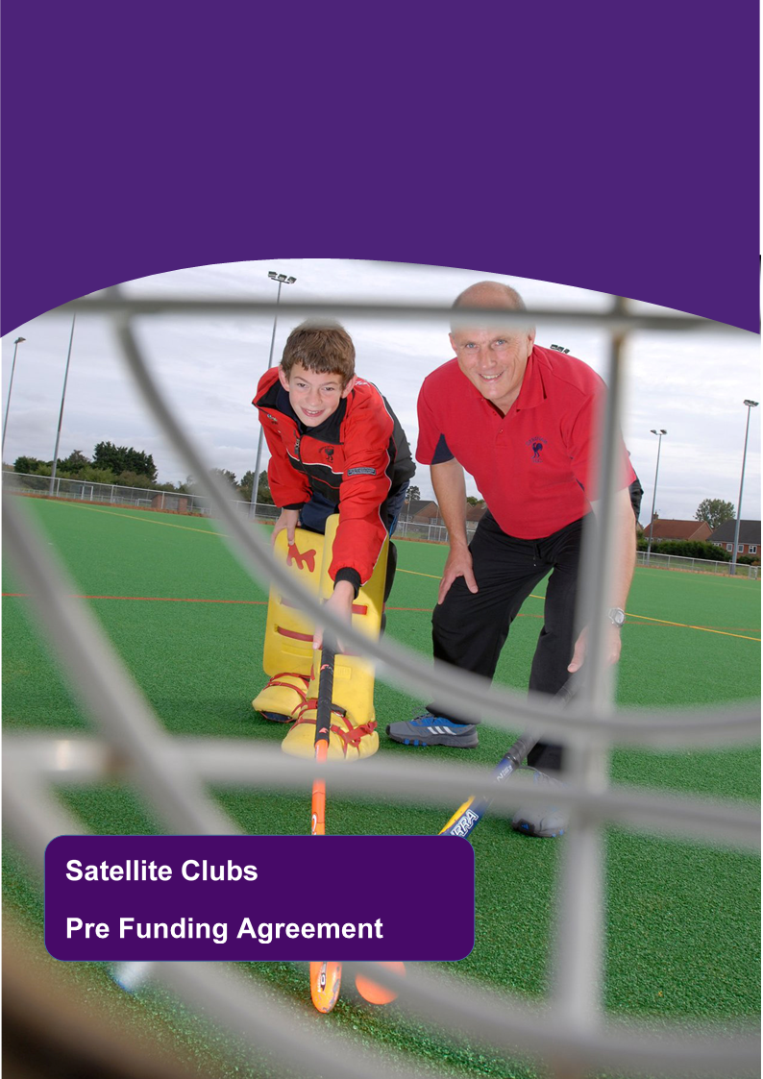

**Satellite Clubs**

**Pre-Application Information**

**What is the Satellite Club programme?**

Satellite Clubs are local sport and physical activity clubs that are designed around the needs of young people and provide them with positive, enjoyable experiences that make it easy for them to become active or to develop more regular activity habits.

Satellite Clubs should provide positive experiences for young people and help them create regular activity habits that will last throughout their lives.

**Satellite Club principles:**

* Satellite Club delivery must be focused on young people aged 14-19.
* Satellite Clubs should be targeted at helping these young people become active or build regular activity habits and / or targeting under-represented groups in sport. These include, but are not limited to females, young people with disabilities and those from lower socio-economic groups.
* Activity provided through Satellite Clubs should be aligned to achieving the Chief Medical Officers recommendation of delivering moderate to vigorous intensity physical activity.
* Positioned to be able to support young people at points of disruption in their lives.
* Designed to get young people active and create regular activity habits.
* Be young people (customer) led including involving young people in decisions and design.
* Be linked to or developed into a regular sport and / or physical activity opportunity.
* Appropriate safeguarding standards must be in place.

**Evidence of consultation**

Understanding what is important to young people and what their needs and wishes are is the first step when developing a Satellite Club opportunity. Satellite clubs must be designed to meet the needs of participants and provide a positive fun experience, giving young people the confidence to take part.

To successfully access Satellite Club funding, applicants must carry out and evidence that the target audience has been involved in shaping the potential Satellite Club.

***Who will you consult with –***For example are you working with all females, males or a mixed group? How many young people did you consult with? Do the young people already take part in physical activity or are they predominantly inactive and do you already work with these young people?

***How will you consult with your target group*** – Think about how you gather the information from young people. For example questionnaires, focus groups or individual conversations with young people

***How will you act on what you are told* –** You will need to be able to evidence that your plans are shaped by the participants, and that their views on the activity, place, costs etc are taken into account when shaping your plan.

**The Funding**

It is anticipated that a maximum amount of £3000 will be available per Satellite Club.

It is likely that your costs will fall under the following headings:

|  |  |
| --- | --- |
| **Category** | **Explanation** |
| Coaching | Provision of high quality coaching for young people by qualified individuals. |
| Participation support | Young people from hard to reach groups have told us that they would feel more comfortable with sessions delivered by or alongside a trusted person they know. Funding is available for members of staff to support recruitment and transition to the Satellite Club. |
| Facility hire | Can be used to cover the cost of facility hire where the Satellite Club takes place. |
| Equipment | To cover the initial costs of equipment to start the Satellite Club. |
| Training and qualifications | This covers the cost of any sports related qualifications for staff and volunteers involved in the delivery of the Satellite Club activity. |
| Other | This funding can contribute to incentives for young people attending on a regular basis. It can support access to memberships to local clubs or activities for young people who would like to become more active. |

**Sustainability**

The Satellite Club funding is designed to kick start a long term participation opportunity. This funding should provide one year of activity if spent well. However a stipulation of the funding is that activity continues beyond the point where funding runs out. You will need to consider how you will sustain the activity itself and the participation of young people in the longer term. For example by:

***Attracting new funding –*** If you know you will need additional funding to continue delivery in the long term you could plan to do this by attracting additional grant funding or sponsorship.

***Fundraising -*** You may plan to raise additional funds through fundraising events throughout the year or charge participants a weekly fee or membership fee

***Self Sustaining*** ***–*** Your club could be sustained without funding for example by charging a weekly fee or having staff trained so you do not have to pay for external coaches. County Durham Sport may be able to help you secure funding for training to sustain the activity beyond the initial funding period.

***Sustained participation*** – We would also like you to think about how you will support participants to continue participating in sport and physical activity. Your plan maybe to retain participants within your Satellite Club. You may wish to create a link with a local sports club, so young people can access more sport. You may also wish to consider being aware of other local opportunities in local leisure centres, community centres or hall and support young people to attend these sessions if they want to try something new. It is important that you have consulted young people on this area, as they may be able to identify a local exit route they would be interested in.

If you would like to discuss your ideas, and are considering applying for satellite club funding then please complete an expression of interest and return it to County Durham Sport, someone will then be in touch to discuss your ideas.

**2019/20 Satellite Club Programme**

**Expression of Interest Form**

|  |
| --- |
| **Deliverer / Organisation name:**  **Main Contact name:**  **Email Address:**  **Contact Number:**  **Location / venue of project:** |

|  |
| --- |
| **Target audience – Satellite funding for 14-19 (other age groups not excluded)**  **Gender:**  **Age Range:**  **Activity Level (Irregularly active, consistently inactive):**  **Disability:** |

|  |
| --- |
| **What will the project involve? (Sport, setting, which partners will you be working with? NGBs, other partners?)** |

|  |
| --- |
| **What is the main outcomes of the project: E.g. Improve mental health, raise physical activity levels, create new opportunity for specific group etc.?** |
|
|
|
|

|  |
| --- |
| **How have you consulted with your target audience? If you haven’t already done this, how do you intend to consult? How will you use Sport England’s research into understanding audiences?** |

|  |
| --- |
| **Approximate cost of project? (Including match funding)**  **Coaching / Staffing –**  **Equipment / Incentives –**  **Facility Hire –**  **Training / CPD -**  **Other (please state) –** |

|  |
| --- |
| **Engagement and retention target (How many people are you likely to engage and retain with this project?)** |

|  |
| --- |
| **How will you support sustainability to keep the participants active beyond the initial funding period?** |

|  |
| --- |
| **How will participation be monitored? Who will be responsible for recording this information and submitting it to County Durham Sport for funding purposes?** |

Please return your expression of interest form to [hello@countydurhamsport.com](mailto:hello@countydurhamsport.com) marked for the attention of Satellite Clubs.