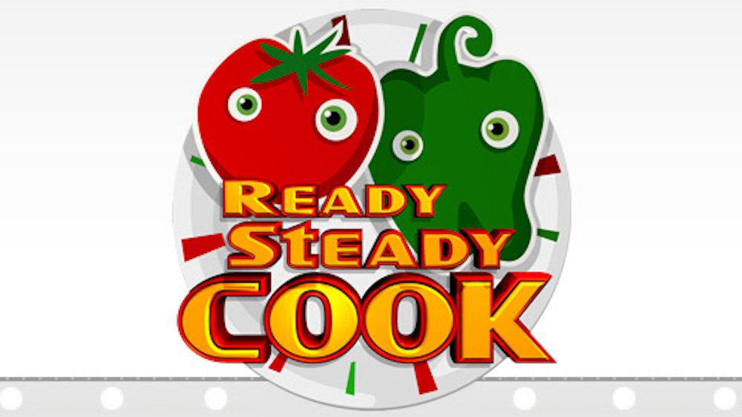

Compete against your friends and family or play yourself as you try to create delicious meals from a list of ingredients.
Aim: Pick a card and set a timer for 2 minutes (you can make the time longer or shorter to make it easier or harder). Read the list of ingredients and create a meal with them before your time is up. You don’t have to use all of your ingredients.
Playing in pairs: If you are playing in pairs, you both create an idea from the same card and then vote to see who creates the best meal.
Playing in a group: All other players use the same card to create a meal and one person acts as the judge and decides which player has created the best meal.
Making the game last longer: Rather than setting a short timer, give each player one of the challenge cards and ask them to go away and research their ingredient. They can research what the ingredient is, where it comes from (i.e. animal or plant, country of origin) and what meals it can be used for.
Progression: Use the Eat Well Guide document attached to try and match the ingredients to the correct food group.
Can your children identify the vegetarian options or meals that could have come from a different country?
Feedback: Take some photographs of you and your family playing the game or carrying out your research and email them to your tutor. Don’t forget to share some of your meal ideas or photograph anything you write down.
Complete the reflection sheet attached after you have completed the activity and email the sheet to your tutor.
Breakfast ingredients

Bacon  Tomatoes  Mushrooms  Brown bread  Eggs | Eggs  Butter  Brown bread  Tomato ketchup  Brown sauce | Sweet waffles  Strawberries  Bananas  Yoghurt | Eggs  Mushrooms  Tomatoes  Milk  Spring onions
Milk  Porridge oats  Grated carrots  Cinnamon  Raisins  Grated apple | Almond milk  Porridge oats  Berries  Honey | Potatoes  Eggs  Onion  Oil  Bacon | Flour  Milk  Eggs  Sugar  Pineapple  Yoghurt
Tortillas  Baked beans  Vegetarian sausages  Mushrooms | Crumpets  Mixed berries  Yoghurt  Maple syrup | Bananas  Eggs  Baking powder  Berries  Honey | Mixed nuts  Oats  Chocolate chips  Dried fruit  Milk
Smoked salmon  Bread  Butter  Eggs | Apples  Pears  Peaches  Grapes  Yoghurt | Salami  Ham  Smoked cheese  Bread buns  Low fat spread | Rice  Ham  Vegetables  Noodles  Eggs
Croissants  Cheese  Ham  Jam  Butter  Honey | Kippers  Bread  Potatoes  Rice  Lemon | Bagels  Jam  Butter  Bacon  Chocolate spread  Soft cheese | Beans  Bread  Mushrooms  Tomatoes  Onions

Lunch or Tea options

Brown pasta  Pork mince  Tinned tomatoes  Mushrooms  Carrots  Onions | Rice  Eggs  Beef  Soy sauce  Mixed veg  Black bean sauce | White cod  Bread  Green peas  Lemons  Potatoes | Beef mince  Brown rice  Kidney beans  Peppers  Chilli powder  Baked beans
Couscous  Tuna  Red onions  Yellow peppers  Stock cubes  Sweetcorn | Eggs  Ham  Cheese  Cherry tomatoes  Spring onions | Flour  Milk  Eggs  Cheese  Tuna  Mayonnaise | Tortillas  Tomato puree  Pepperoni or chicken  Cheese  Peppers  Onions
Brown pitta breads  Sliced turkey  Lettuce  Tomatoes  Soft cheese or mayonnaise | Prawns  Chicken  Rice  Mixed vegetables  Onions  Herbs and spices | Leek  Potatoes  Vegetable stock  Carrots  Onions  Celery | Egg  Bread  Grated carrots  Grated potatoes  Sweetcorn  Peas
Flour  Milk  Eggs  Sausages  Potatoes  Gravy granules | Chicken strips  Tortillas  Fajita mix  Onions  Peppers | Beef joint  Potatoes  Broccoli  Carrots  Gravy  Peas | Pork chops  Sweet potatoes  Tomatoes  Onions  Baked beans
Bacon  Leeks  Macaroni  Cheese  White sauce | Curry paste  Fish  Rice  Mixed vegetables  Naan breads  Coconut milk | Kidney beans  Baked beans  Black eye beans  Pasata  Chilli powder  Potatoes | Mince  Bread buns  Sweet potatoes  Lettuce  Tomato  Red onions

Snack options

Chickpeas  Olive oil  Tahini  Carrots  Cucumber  Peppers | Grapes  Strawberries  Bananas  Kiwis  Apples  Blueberries | Brazil nuts  Almonds  Raisins  Cranberries  Pistachios  Chocolate chips | Porridge oats  Honey  Butter  Raisins  Seeds  Nuts
Mixed berries  Greek yoghurt  Honey  Ice | Savoury pancakes  Cucumber slices  Soft cheese  Grated carrots  Sliced spring onion | Oats  Coconut pieces  Chocolate chips  Protein powder  Honey | Eggs  Butter  Milk  Brown bread  Tomatoes
Flour  Eggs  Milk  Sugar  Strawberries  Chocolate spread | Avocado  Bananas  Milk  Sourdough bread  Honey | Cherry tomatoes  Onions  Garlic  Fresh coriander  Lime  Nachos | Yoghurt  Berries  Strawberries  Honey  Granola
Bananas  Chopped mixed nuts  Chopped milk or dark chocolate  Crushed cornflakes | Eggs  Sugar  Flour  Butter  Jam  Sprinkles | Peanut butter  Jam  Bread | Chopped tomatoes  Ciabatta  Cheese  Garlic clove  Fresh parsley
Digestive biscuits  Greek yoghurt  Bananas  Caramel  Honey | Mango  Banana  Peach  Apples  Yoghurt or milk | Rice cakes  Cucumbers  Soft cheese  Peanut butter  Peppers | Popcorn kernels  Salt  Sugar  Cinnamon  Honey  Paprika

Challenge cards

Salmon and curry powder | Gnocchi
Calamari | Enchilada kit
Halloumi | Butternut squash
Arborio rice | Quorn chicken strips
Red lentils | Monkfish

