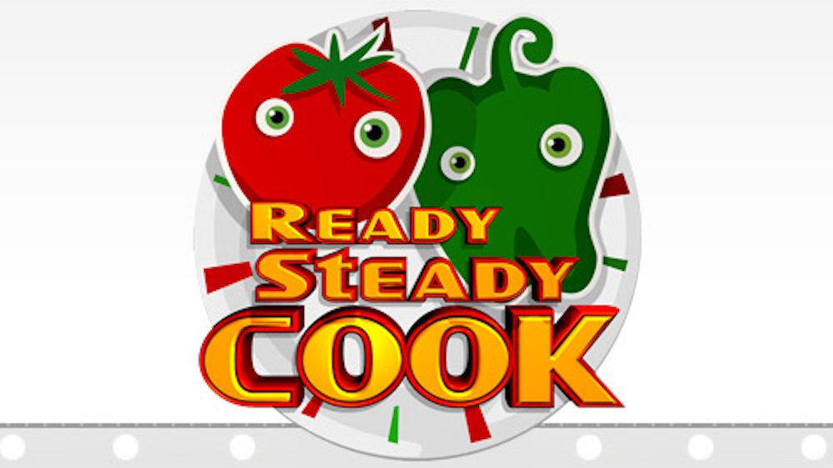

REVIEW SHEET
Please complete the review sheet once you have completed the task.

Did you enjoy this task? Explain your reason for your answer.

Who completed the task?

What was the strangest meal that was created?

What did you notice about your knowledge of this topic when completing the task?

What did you notice about the children’s knowledge of this topic when completing the task?

Did you complete the progression task?

Were you able to match the foods to the correct food groups?

How many vegetarian meals did you create?

How many meals did you create from different countries?

Having completed the activity, what other information would you and your family like to know about food and nutrition?

